BELT ADVANCEMENT REWORK
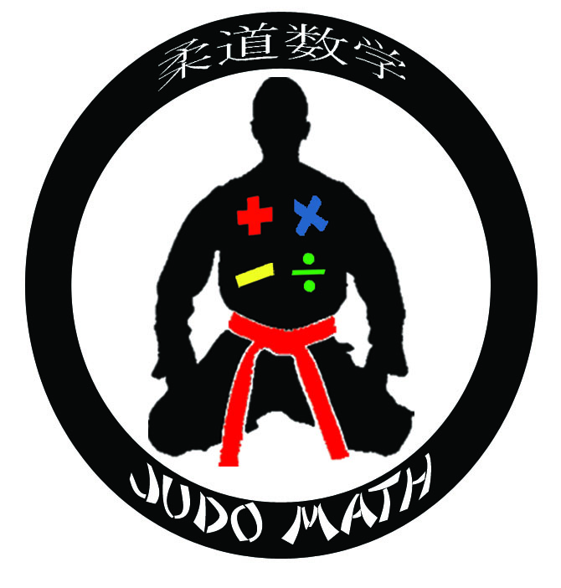Name___________________________Class______________________________ Belt Test Color_____________

QUESTION # _______ MATH REWORK

EXPLANATION: What mistakes did you make? Be SPECIFIC. What should you have done instead? If you didn’t know how to solve the problem, explain how to solve it, now that you do know how.

------------------------------------------------------------------------------------------------------------------------------------
QUESTION # _______ MATH REWORK

EXPLANATION: What mistakes did you make? Be SPECIFIC. What should you have done instead? If you didn’t know how to solve the problem, explain how to solve it, now that you do know how.

QUESTION # _______ MATH REWORK

EXPLANATION: What mistakes did you make? Be SPECIFIC. What should you have done instead? If you didn’t know how to solve the problem, explain how to solve it, now that you do know how.

------------------------------------------------------------------------------------------------------------------------------------
QUESTION # _______ MATH REWORK

EXPLANATION: What mistakes did you make? Be SPECIFIC. What should you have done instead? If you didn’t know how to solve the problem, explain how to solve it, now that you do know how.

